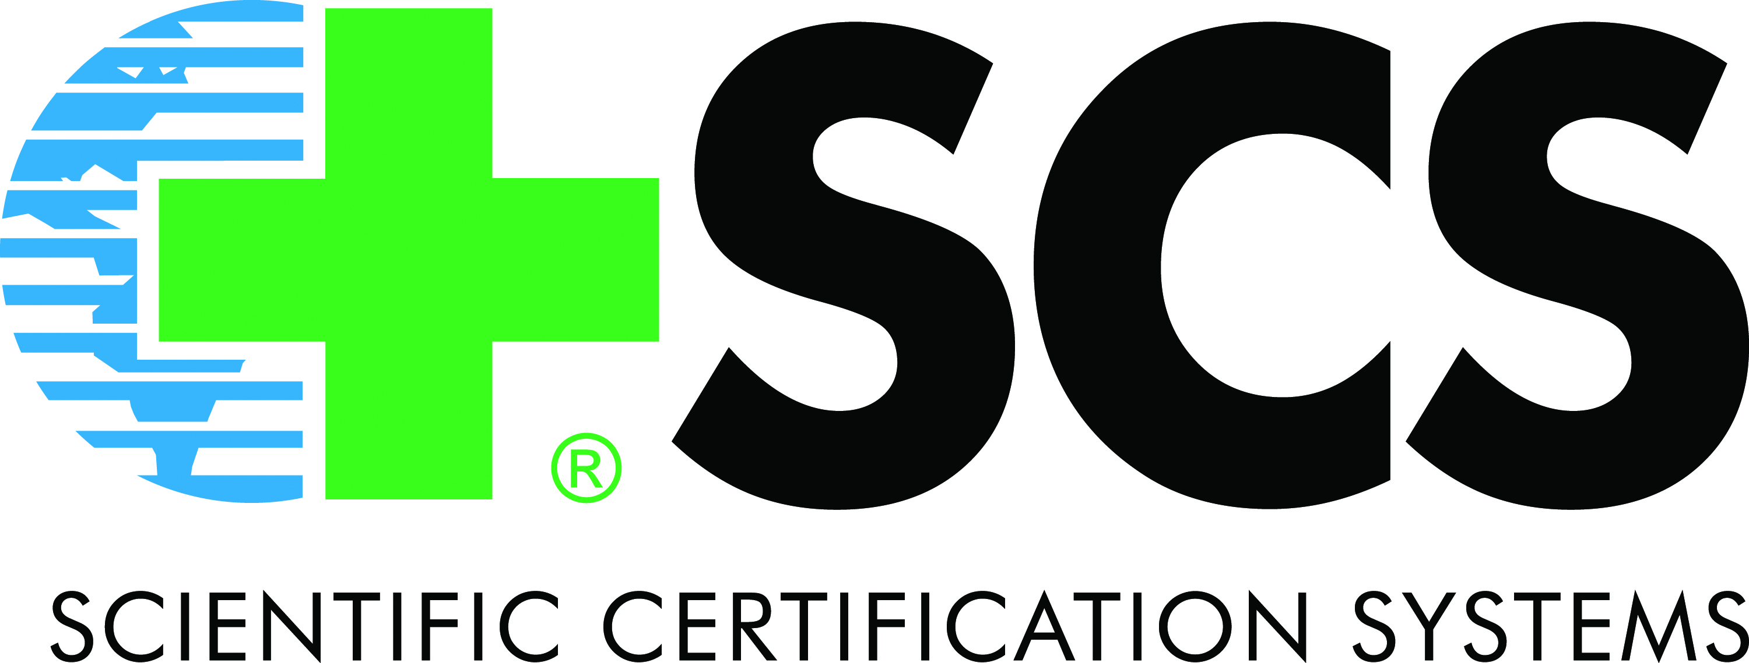

Food and Agricultural Services (SCS-FAS)
Food Safety Certification Manual
for SQF 1000 and SQF 2000

Scientific Certification Systems
V4-1

Scientific Certification Systems
2000 Powell St., Suite 600, Emeryville, CA 94608
www.scscertified.com
SQF Certification

Thank you for your interest in Scientific Certification Systems (SCS) Safe Quality Food (SQF) program. We are pleased that you are considering SCS as your certifier. SCS offers fast turnaround, competitive rates, attentive service and value for your money. We have a dedicated team of professionals and skilled auditors ready to assist you with all your SQF certification needs.

The first step in pursuing certification will be to complete an SCS Application located at: http://www.scscertified.com/fff/food_safety.php and our SQF 1000 or 2000 Questionnaire. Upon receipt of your application and questionnaire, we will scope and source the services requested by your company and shortly thereafter provide you with our proposal. Both SQF 1000 and 2000 codes are based on HACCP methods and principles, and both levels provide a risk management system with reduced paperwork and audit burdens. SQF 1000 is for primary producers and growers and is designed as a certification for products entering into an SQF certified business. SQF 2000 is for the manufacturing, processing and distribution sectors.
We recommend that you review the following documents at a minimum, (found at http://www.sqfi.com/documents), which contain the requirements for certification based on the SQF code you select to comply with in order to obtain certification:
- For SQF 1000 Certification, please review:
SQF 1000 Code
SQF Audit Duration Guide
SQF 1000 Certification Trade Mark Rules for Use
- For SQF 2000 Certification, please review:
SQF 2000 Code
SQF Audit Duration Guide
SQF Guidance for Developing, Documenting and Implementing SQF 2000 Systems
SQF 2000 Certification Trade Mark Rules for Use

In pursuing certification, key determinants of timely processing include submitting the SCS Application & Questionnaire, obtaining a working knowledge of the SQF 1000 and/or 2000 code, submitting your documents for the Desk Audit and coordinating closely with SCS to set an on-site audit date.

Our fees for SQF certification are based on our commitment to making certification services cost-effective for all prospective clients, both large and small. Our charges are reflective of actual work performed, within a limited sliding scale fee structure. To prevent any potential conflict of interest, SCS charges for its certification reviews whether or not a certification is ultimately granted. This policy ensures that there is no incentive to issue certifications that are not earned.

Please contact our offices if you have any questions regarding the certification process.

SCS, Food Safety Auditing
Phone: 510.452.8000

Key Terms

SQFI has an extensive Program Vocabulary document which can be found here:
SQF Program Vocabulary

Certification — Certification by a Certification Body of the Producer’s/Supplier’s SQF Systems as complying with the SQF Code, as appropriate, following a Certification Audit, or Recertification, and Certify, Certifies and Certified shall have a corresponding meaning.

Certification Audit — an Audit of Producer’s Supplier’s whole SQF System, including Desk Audit, where the Producer/Supplier of SQF Systems:
- has not been previously certified; or
- has been previously certified but requires certification as the earlier certification has been revoked or voluntarily discontinued by the Supplier

Corrective Action Plan (CAP) — Plan prepared by the client on how to resolve non-conformities.

Desk Audit - A review of Producer’s/Supplier’s SQF System documentation, part of and the initial stage of the Certification Audit. A desk audit ensures the system documentation substantially meets the requirements of the SQF Code, as appropriate.

HACCP Method - Implementation of the Pre-requisite Programs and the application of HACCP Principles in the logical sequence of the 12 steps as described in the current edition of the CODEX Alimentarius Commission Guidelines, or the current edition of the HACCP guidelines developed and managed by the NACMCF. Both the SQF 1000 code and the SQF 2000 codes use the HACCP method to control food safety and other quality hazards in the segment of the food chain under construction.

Non-Conformity - A failure to meet the requirements of the Standard. Non-conformities are divided into three types; minor, major and critical.

Re-Certification Audit - an audit of the Producer’s/Supplier’s SQF System within 30 days of the anniversary of the certification.

Scope of Certification – Outlines the Food Sector Categories and those Products to be covered by the Certificate of Registration.

Surveillance Audit - means a six monthly Audit (or more frequently as determined by the Certification Body) of part of a Supplier’s SQF System where that system has previously been Certified or Re-Certified and whose Certification is current. Multi-site Certification requires Surveillance Audits every six months at a minimum.

Multi-Sites (SQF 1000 and 2000) - A multi-site organization is comprised of a Central-site under which activities are planned to manage and control the food safety and quality management systems of a network of Sub-sites under a legal or contractual link. The Central-site is the entity responsible for the Multi-site Organization. Sub-sites shall be linked to the Central-site by a legal or contractual arrangement.

SQF 1000 & 2000 Food Safety
Certification Program Process Diagram

Applicant is provided with: Initial Application Form, SQF 1000 or 2000 Questionnaire, SCS-FAS Certification Manual, and Fee Schedule.

Application Stage

Applicant completes and submits: Initial Application Form and SQF 1000 or 2000 Questionnaire.

SCS provides the applicant with a Work Order and the SCS Assessment Services Agreement. Applicant signs and returns both.

SCS issues an Invoice for 50% of the audit fee. Client must remit payment before evaluation can proceed.

For Initial Client, a Desk Audit is conducted: SCS reviews the Initial Application Form and supporting documents. Based on this review, SCS determines the feasibility of moving forward toward Certification.
Evaluation and Reporting Stage

Certification Audit
- Audit of Client’s whole SQF System, including Desk Audit
- SQF accredited auditor conducts on-site inspection which includes: reviewing documents, evidence gathering, and interviews. During the closing meeting, the SQF auditor will provide the Client with a Non-Conformance Summary sheet.
- SQF accredited auditor prepares the report of findings and identification of critical, major and minor non-conformities.

Client commits to a timetable to correct minor, major and critical CARs.

SCS issues certification decision and provides Client with certification information and documentation. Certification status is logged on SQFI website (www.sqfi.com).
Certification Decision Stage

- Certification Process
Surveillance audit confirmed (via Work Order) and conducted six months (or more frequently based on findings) after certification decision has been made by SQF accredited auditor. Multi-site organization shall be subject to a 6 monthly surveillance audit.

Surveillance Audit
Re-Certification Audit
Re-Certification audit confirmed (via Work Order) and conducted; Audit Report prepared by SQF accredited auditor.

Applicants enter into a 3-stage certification process, the Application Stage, Evaluation and Reporting Stage, and Certification Decision Stage.

Application Stage:

  - During the Application Stage, the SCS Application Form and SQF 1000 or 2000 Questionnaire is completed and submitted. During this stage the SCS Fee Schedule is made available to the Applicant. (Completed forms can be emailed, mailed or faxed).
  - Upon receipt of the SCS Application Form and the SQF 1000 or 2000 Questionnaire, SCS will provide the Applicant with a Work Order and the SCS Assessment Services Agreement. Applicant signs and returns both documents.
  - SCS issues an invoice for 50% of the audit fee. Client must remit payment before evaluation can proceed.

Evaluation and Reporting Stage:

- For Clients entering the Evaluation and Reporting Stage, a Certification Audit will be scheduled. The Certification Audit will include both a Desk Audit (Off-Site) and an On-Site Inspection,
  - Internal Audit: The Client must conduct an internal audit using the relevant SQF Self-Assessment Checklist.
  - Desk Audit (or Document Review Audit): This audit is conducted offsite. The Client must submit documents to SCS according to the SQF Document Review Checklist. This can be found on the SQF 1000 or 2000 Questionnaire. SCS shall notify the Client of corrections or corrective actions. All critical and major and/or minor nonconformities discovered during the Document Review Audit must be resolved before the On-Site Audit can take place. Minor non-conformances may be carried over to the On-Site Audit, but must be closed out prior to the conclusion of Certification Audit.
  - On-Site Inspection: SCS will work with the client to schedule the on-site Certification Audit. An Audit Plan will be sent by SCS prior to the inspection after all major, critical and/or minor nonconformities are closed.

Certification Decision Stage:

- During the Certification Decision Stage, the SCS auditor prepares a report of findings at the time of the inspection, validating the criteria that have been met and identifying areas where additional work is needed under a series of non-conformities. (Refer to the Evaluation of Findings Addendum at the end of this document for a process flow chart.)
- The SCS auditor completes the audit checklist, including the Producer Details section and the Audit Summary section where details of corrective actions and types of nonconformities are documented. Nonconformities may be minor, major and critical, requiring a timeframe for correction.
- The Client prepares the Corrective Action Plan (CAP).
- The Final Decision to issue new Certification, extend an existing Certification, or deny/suspend/revoke an existing Certification is made by SCS.
  - For Level 3: The SQFI Logo shall be issued.
  - Suppliers consent to have their certification or registration details displayed on the SQFI website.

Maintaining Certification & Audit Frequency

To maintain certification, a Client is required to attain a “C” (Comply) Audit rating or greater, ensure the number and type of nonconformities detected during the Audit does not exceed the threshold level and ensure all nonconformities are corrected within the timeframe specified.

Audit Frequency is determined by the Client’s SQF System rating and the type/number of nonconformities detected during a Certification or Re-Certification Audit. Refer to Tables 4 and 5 in the current edition of the SQF 2000 code (page 65) and Table 5 in the current edition of the SQF 1000 code (page 51).

Generally, SQF 1000 and 2000 Re-Certification Audits are conducted annually. A 60 day period (30 days either side of the initial date of certification) is provided to allow SCS to complete the audit. Before Re-Certification, the Client is required to correct any non-conformances found during the audit and SCS shall close out the non-conformances and post the Client’s certification details on the SQFI database. This audit verifies the continued effectiveness of the Client’s SQF System in its entirety. The Re-Certification Audit shall provide for a review of past performance of the SQF System and is conducted annually on the anniversary date of the issue of the initial Certification.

A Surveillance Audit is conducted when the results of a Certification or Re-Certification Audit do not support an annual audit frequency. An audit rating of “C” will require a Surveillance Audit every 6 months until an appropriate audit result is achieved. Multi-Sites must have a Surveillance Audit conducted every 6 months.

The purpose of the Surveillance Audit is to:

- Verify that outstanding Corrections and Corrective Actions have been appropriately addressed and to close-out outstanding Non-conformities;
- Verify that the SQF System continues to be implemented as documented;
- Consider and take appropriate actions where changes to the supplier’s operations are made and the impact of these changes on the supplier’s SQF System;
- Confirm continued compliance with the requirements of the relevant SQF code;
- Verify that all critical steps remain under control; and
- Contribute to continued improvement of the Supplier’s SQF System and business operation.

Multi-Sites (SQF 1000 and 2000)
After successful completion of a Certification audit and subsequent Re-certification Audits, the Multi-site organization shall be subject to a 6 monthly Surveillance Audit.

